Project Title:Real-Time Communication System Powered by AI for Specially Abled Project Design Phase-I -Solution Fit Template Team ID:PNT2022TMID06949

Specially abled persons. Implanted electronic medical device that can produce useful hearing sensation by electrically simulating nerves inside the inner ear.

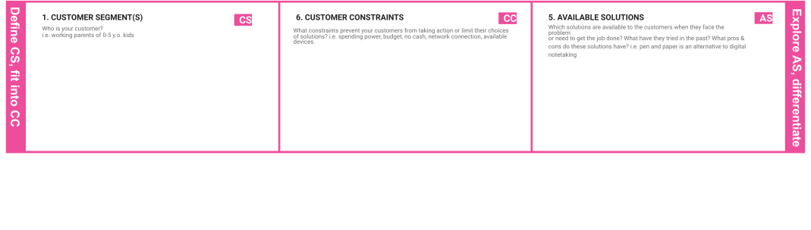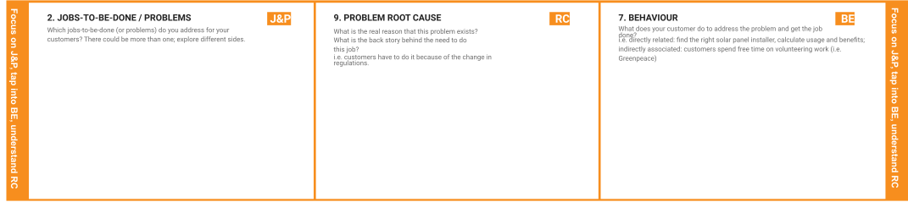

The first ever approach to sign language it has only 6 sign gestures detection.As AI takes an important role in communication and interaction,the use of this technology enables individuals with disabilities to access information much easier,all just by speaking to their devices.

Deaf and dumb people couldn’t able to convey their messages to the normal people easily.

Deaf people cannot hear the words as others speaks and dumb people cannot express their feelings by words. Concentrate on making their communication much easier and live a normal life.

Disabilities affect the entire family. Meeting the complex needs of a person with a disability can put families under a great deal of stress — emotional, financial, and sometimes even physical. However, finding resources, knowing what to expect, and planning for the future can greatly improve overall quality of life

In our device, there's an option called problem detection display in which our customer can able to see the type of problem occurs & solution will be displayed.

|  |  |  |  |  |
| --- | --- | --- | --- | --- |
|  | **3. TRIGGERS TR** | **10. YOUR SOLUTION SL**  If you are working on an existing business, write down your current solution ﬁrst, ﬁll in the canvas, and check how much it ﬁts reality.  If you are working on a new business proposition, then keep it blank until you ﬁll in the canvas and come up with a solution that ﬁts within customer limitations, solves a problem and matches customer behaviour.  Facial recognition,voice recognition and predictive texting tools allows people who have difficulties in speaking to communicate more easily using AI.We can also use AI sensors to monitor their heslth conditions regularly and save the health reports for future purposes in a separate database. | 1. **CHANNELS of BEHAVIOUR CH**    1. **ONLINE**   What kind of actions do customers take online? Extract online channels from #7  Advertise on online with influencers to test the product and promote it also on social medias.  8.2OFFLINE  What kind of actions do customers take ofﬂine? Extract ofﬂine channels from #7 and use them for customer development. |  |
| What triggers customers to act? i.e. seeing their neighbour installing solar panels, reading about a more efﬁcient solution in the  news. |
| By comparing normal people,Specially Abled  people should depend on others and want to live their life independently like other people |
| **4. EMOTIONS: BEFORE / AFTER EM** |
| How do customers feel when they face a problem or a job and afterwards?  i.e. lost, insecure > conﬁdent, in control - use it in your communication strategy & design. |
| BEFORE: It is very difficult to convey the message to normal people.  AFTER: They overcome their reluctance to have communication with normal people. |